[tyesha.leslie@outlook.com](mailto:tyesha.leslie@outlook.com)

#11 Calvary Hill ,Arima

(868-**392-9399) n** 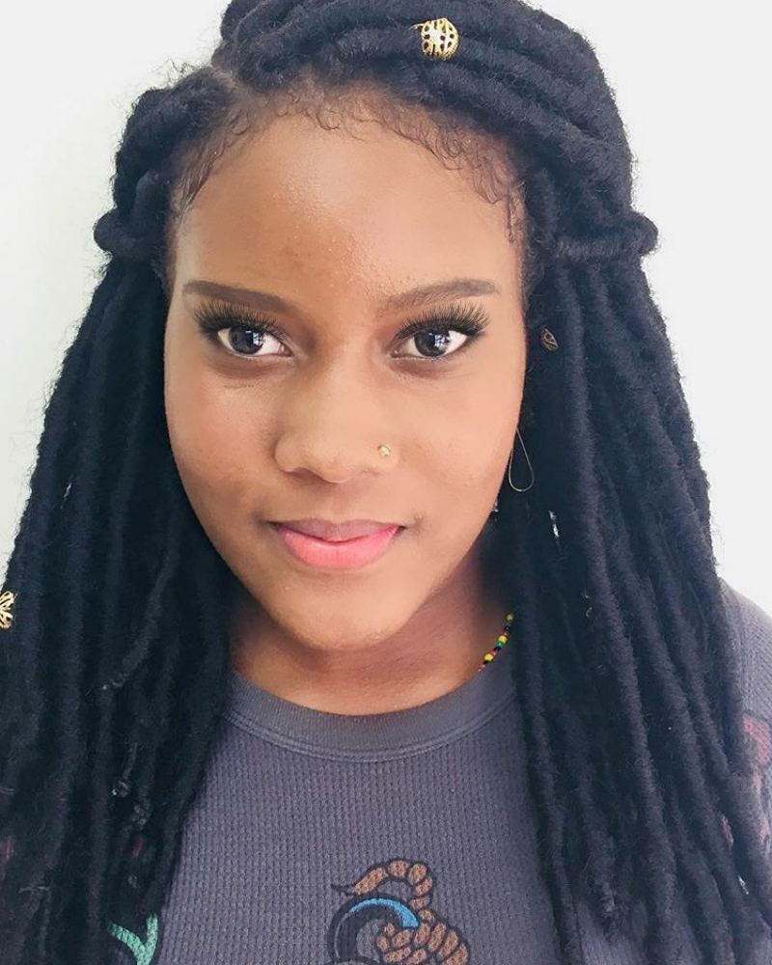

Tyesha Deborah Leslie

|  |  |
| --- | --- |
| **Summary/Objective**  **Education**  **References** | **To use my skills and qualifications to better this organization and to develop my independence and economic stability**   * Interpersonal Skills: Able to get along well with co-workers and accept supervision. * Flexible * Dependable: Can be counted on to keep one’s word (i.e. show up for work on time, and conduct job duties well, etc). * Trustworthy: Can be trusted to get the job done, to look after things or keep secrets that are very important to other people. * Learns quickly: Willing to carry out new responsibilities easily by watching others or by following instructions. * Follows instructions well: asks questions when instructions are not fully understood.   **Tertiary**  UWI Open Campus  2016-2017  Certificate in social work  UWI St. Augustine  Bachelor’s Degree in Social work  2017-present  **Secondary**  St. Joseph Secondary  English (II)  Social studies (II)  Agricultural science (II)  Integrated science (II)  Mathematics(III)  Cosmetology -CVQ level 1 Certificate    **Julie Perryman**  **Woman police corporal**  **(868)-343-3162**  **Sandra Borde**  **Retired principal**  **(868)-281-0818** |
|  |  |
|  |  |
|  |  |
|  |  |
|  |  |